Application Development
- Individual Coursework Report –

SmartMed Pharmacy System

Module Leader : Ms.Shifani Mohideen
Student : M.N Sahla Baanu – E301118 [25045082]


Course Submission Cover Sheet

Module: Application Development

Assignment no: 001

Weighting: 100% of the module mark

Deadline: 11.59 PM Tuesday the 30th June 2026
Module Leader: Ms.Shifani Mohideen Student ID: E301118 / 25045082
Please note that there are specific regulations concerning the use of AI and Academic Misconduct. Below are extracts from these regulations. By signing, you acknowledge that you have read and understood these extracts.
(signature:) M.N Sahla Baanu Date: 30/06/2026
This header sheet should be attached to the work you submit.
Academic Integrity means being honest in your academic work and your studies and making sure that you acknowledge the work of others and giving credit where you have used other people's ideas as part of presenting your arguments. Your assessment submissions must therefore always be entirely your own work, based on your own learning and appropriately referenced including how you have used Generative AI. The University regards the use of Generative AI applications by students to deceive to gain unfair advantage as academic misconduct. This usage includes:

- Plagiarism, where AI tools are used to generate output and ideas that are presented or submitted as if they were the student's own work, without proper citation or references.
- Where a complete assignment is created using Generative AI and represented as a student's own work, this will be regarded as contract cheating in the same way as commissioning an 'Essay Mill' or other third party to complete your work. Further information can be found on : Guidance on the use of Artificial Intelligence.

Academic misconduct: The University takes academic misconduct very seriously and seeks at all times to rigorously protect its academic standards. Plagiarism, collusion and other forms of cheating constitute academic misconduct, for which there is an explicit range of graduated penalties depending on the particular type of academic misconduct. The penalties that can be applied if academic misconduct is substantiated range from a reprimand to expulsion in very serious cases and for repeated instances of misconduct. You are also responsible for ensuring that all work submitted is your own and that it is appropriately referenced. The University does not tolerate cheating of any kind. You are strongly advised to familiarise yourself with the Academic Misconduct Policy and Procedure (Academic Misconduct), which list a range of categories of academic misconduct and associated penalties, covering instances of academic misconduct (plagiarism, collusion, exam cheating).

Introduction
This report presents SmartMed, a pharmacy management system. The application is intended to help a small pharmacy handle routine work through one Windows desktop program instead of depending on paper records or scattered files. Two user types are supported: an admin who manages the pharmacy operation, and a customer who signs in to use the customer-facing side of the system. Both roles enter through the same login screen, but each user sees only the features relevant to that role.
The system was built using C# with Windows Forms on .NET Framework 4.8, which is well suited to a desktop business application of this kind. Persistent data is stored in a SQL Server database, with ADO.NET used to connect the forms to the database through helper and repository classes. The project structure separates the user interface, business logic, and data access, which makes the codebase easier to follow as features are added. Supporting diagrams such as use case, class, and sequence models were prepared to plan and explain how the system behaves.
The overall aim was to apply object-oriented programming in a practical desktop application that a pharmacy could realistically use. Key goals included reliable login for both roles, keeping stock and order information accurate, and giving the admin useful dashboard and report information without manual calculations. Another priority was to keep the code readable and well organised so that further features could be added later without disrupting existing functionality.

System Requirements

Functional Requirements

Admin
Access the system using secure administrator credentials to perform and manage all pharmacy-related operations.
Maintain medicine information by adding new medicines, updating existing records, removing discontinued medicines, and managing details such as name, category, dosage, price, stock quantity, supplier information, expiry dates, and prescription requirements.
Monitor and manage customer information by viewing customer records and updating customer details when necessary.
Oversee customer orders by viewing all orders placed through the system and updating order statuses from Pending to Ready for Pickup or Delivered.
Monitor pharmacy performance through a dashboard that provides an overview of total sales, available medicine stock, active orders, and other key operational statistics.
Generate and review reports related to sales performance, medicine inventory, and customer order history to support decision-making and operational monitoring.
Create, update, and remove discounts or promotional offers that can be applied to medicines.
Track medicine expiry dates and receive notifications for medicines approaching expiry in order to ensure inventory safety and compliance.

Customer
Create a personal account and securely access the system using registered credentials.
Search and browse available medicines by name, category, or price range and view detailed medicine information before purchasing.
Select medicines, add them to a shopping cart, review selected items, and place orders through the system.
Monitor previously placed orders and track their current status throughout the order processing lifecycle.
Manage personal profile information by viewing and updating personal and contact details.
Upload prescription documents when purchasing medicines that require prescription verification.
View available discounts and promotional offers that can be applied to eligible medicines.
Export personal order history in PDF or Excel format for future reference and record keeping.

Additional Features
Low Stock Alert System - The system will automatically monitor medicine inventory levels and notify administrators when the stock quantity of a medicine falls below a predefined threshold. This helps prevent stock shortages and ensures the availability of essential medicines.
Medicine Expiry Warning Dashboard - The system will identify medicines approaching their expiry dates and display warning notifications on the administrator dashboard. This assists in inventory management and reduces the risk of dispensing expired medicines.
Prescription Verification System - The system will require customers to upload a valid prescription when ordering medicines marked as prescription-required. Orders containing prescription medicines cannot be processed unless the required prescription document has been uploaded and verified.
Password Change Functionality - The system will allow both administrators and customers to securely change their account passwords after successful authentication, improving account security and user management.
Order Cancellation - The system will allow customers to cancel orders that are still in the Pending status. Once an order has been processed or marked as Ready for Pickup, cancellation will no longer be permitted.

Non-Functional Requirements
- Usability - The system shall provide an intuitive and user-friendly interface with role-based navigation, allowing administrators and customers to easily access their respective functionalities through clearly organized forms and menus.
- Reliability - The system shall validate user inputs before processing and use parameterized SQL queries to ensure accurate data handling and prevent database-related errors.
- Maintainability - The system shall follow a three-tier architecture with separate Presentation, Business Logic, and Data Access layers to simplify future maintenance, testing, and enhancements.
- Performance - The system shall provide responsive operation for medicine searches, order processing, and report generation, with search and filtering functionality optimized for typical pharmacy inventory sizes.
- Security - The system shall authenticate users through secure login mechanisms, restrict access based on user roles, and maintain session information for authenticated users.
- Availability - The system shall allow authorized users to access pharmacy services whenever the application and database are operational.
- Scalability - The system shall support future enhancements such as additional user roles, advanced reporting features, and expanded inventory management without major architectural changes.
- Data Integrity - The system shall maintain consistent and accurate data through validation rules, database constraints, and controlled update operations.

Hardware Requirements
- PC or laptop running Windows 10 or later.
- Intel Core i3 processor or equivalent.
- Minimum 4 GB RAM (8 GB recommended for development).
- At least 5 GB of available storage space.

Software Requirements
- Microsoft Windows 10 or later.
- .NET Framework 4.8
- Microsoft SQL Server
- Visual Studio 2019 or later with .NET desktop development workload

Development Tools and Technologies
- Programming Language: C#
- User Interface: Windows Forms
- Database: Microsoft SQL Server
- Data Access Technology: ADO.NET
- Integrated Development Environment (IDE): Visual Studio 2022
- Version Control: Git and GitHub
- Diagramming Tool: Draw.io
- Architecture Pattern: Three-Tier Architecture

Design Diagrams

Architecture Diagram
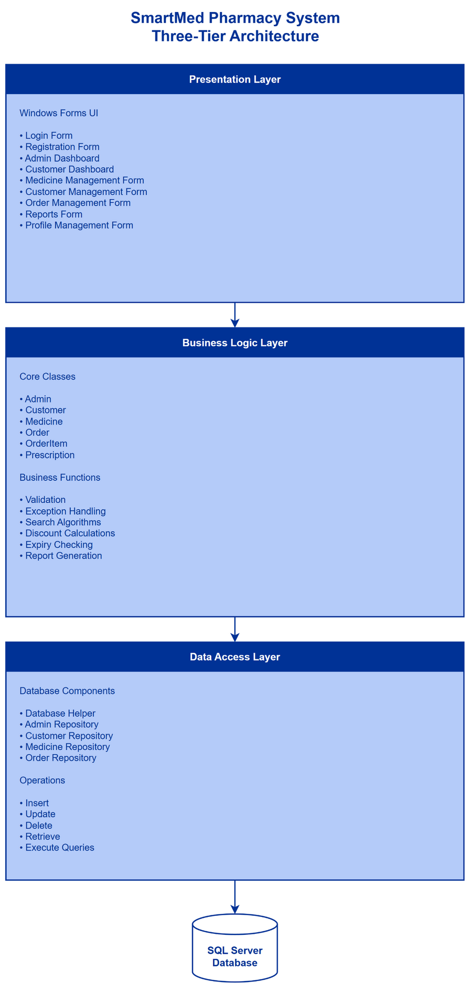
Figure: Architecture Diagram
The architecture diagram was drawn at the start of the project to decide how the application should be split into clear parts before writing code. A layered structure was chosen so that screens, business rules, and database access do not get mixed together, which makes the system easier to build, test, and explain in a coursework report. This approach is common in desktop business applications and matches what was taught about separation of concerns.
The diagram also justified why SmartMed has separate folders for Forms, Services, Data, and Models. Each layer has one main job: the user interface handles clicks and display, services apply pharmacy rules, repositories talk to SQL Server, and model classes simply carry data between those layers. This general structure supported both the admin and customer sides of the application without duplicating database code on every screen.

Use Case Diagram
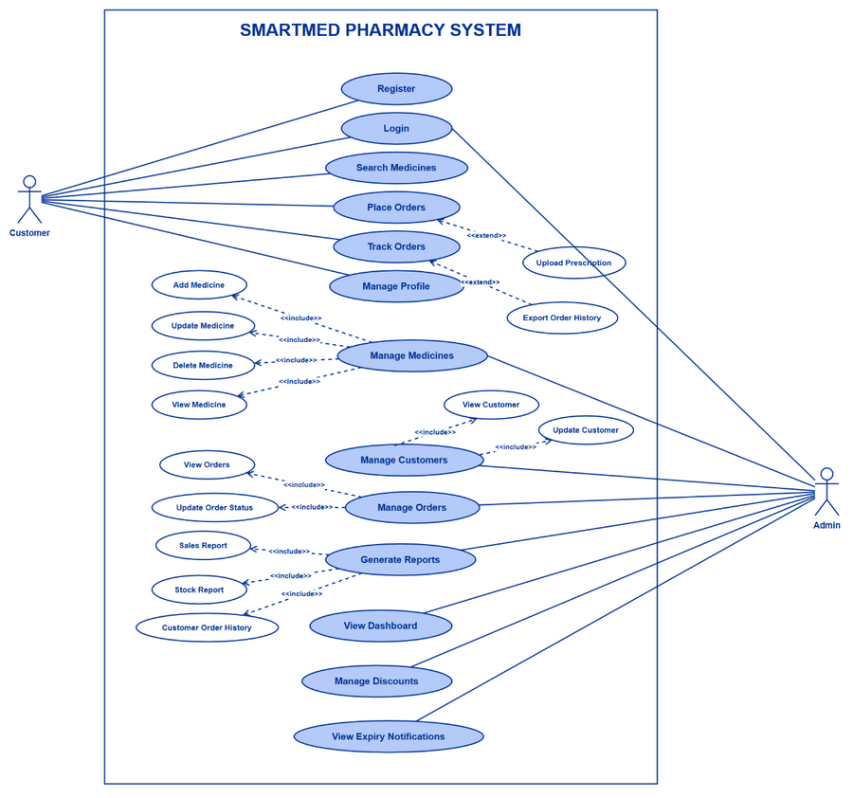
Figure: Use Case Diagram
The use case diagram was created during requirements analysis to confirm that both user roles — admin and customer — have a complete set of features before detailed design began. It gives a high-level, non-technical view of what the system should offer to the outside world, without showing buttons, code, or database tables.
Drawing this diagram early helped justify the scope of SmartMed: admin work (stock, customers, orders, reports) and customer work (register, search, cart, track orders) are clearly separated. It also highlighted relationships such as placing an order depending on searching medicines first, which later guided how the customer screens were grouped in the application.

ER Diagram
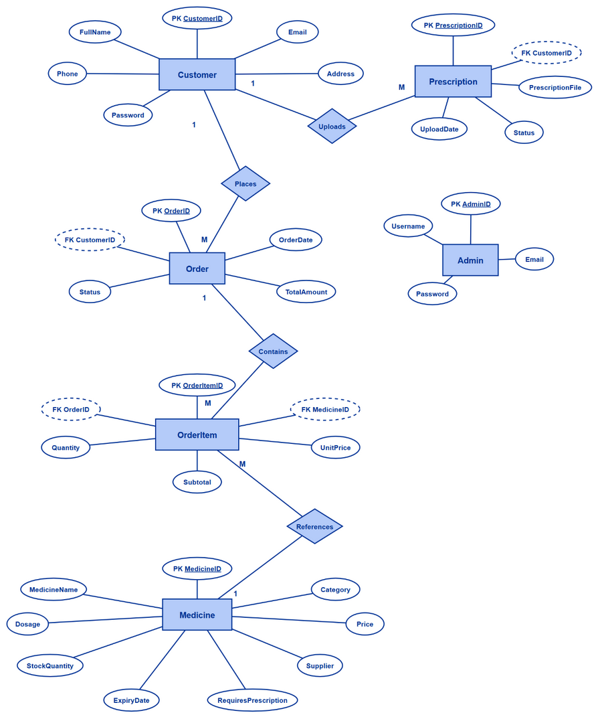
Figure: ER Diagram
An entity-relationship diagram was prepared before writing the SQL script so that data could be stored in a logical and consistent way. The main purpose was to plan how pharmacy records link together — for example, customers place orders, and each order contains line items — so that reports and order history would still make sense after many transactions.
This diagram justified the use of primary keys, foreign keys, and status rules in the database. It reduced the risk of designing tables that could not support real pharmacy operations, such as keeping past order details even when a medicine is later removed from the catalogue.

Class Diagram
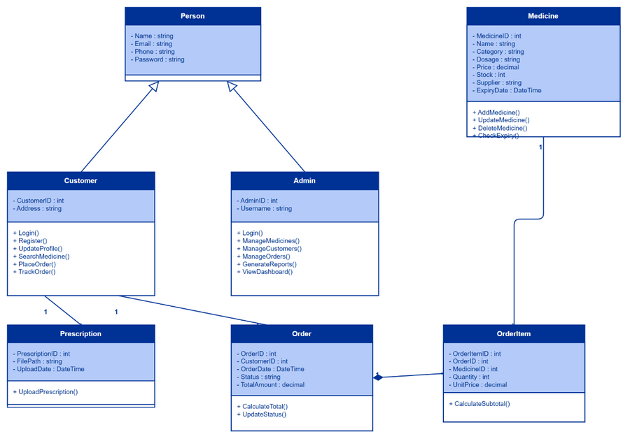
Figure: Class Diagram
The class diagram was used to plan the object-oriented structure of SmartMed before implementation. It shows how domain types relate to one another through inheritance (for example, Admin and Customer extending a common User type) and how services and repositories support those entities.
The diagram justified applying OOP concepts such as generalisation, encapsulation, and class responsibility at design time. It acted as a map from the problem domain to C# classes, even though the final code places most behaviour in service classes rather than inside every model class, which is explained further in the class descriptions section.

Sequence Diagram
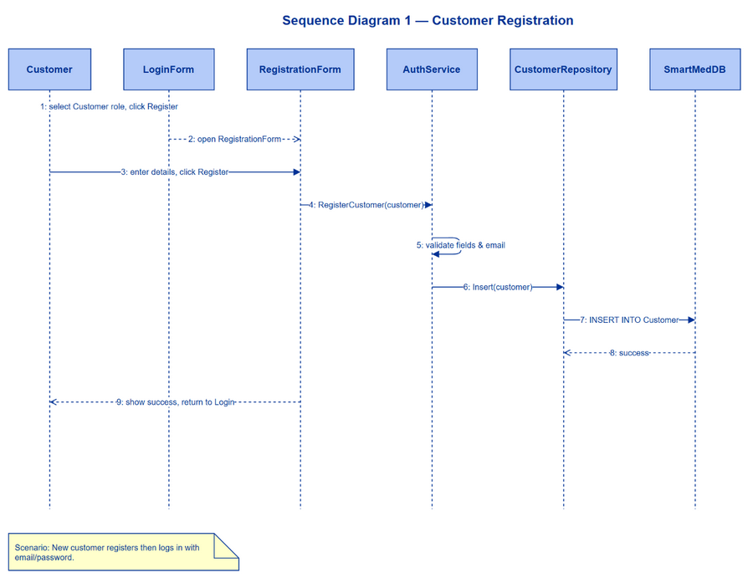
Figure: Sequence Diagram
Sequence diagrams were included to show the time order of interactions for important scenarios such as login, placing an order, and managing medicines. They justify how a user action on a form flows through services and repositories before data reaches the database, which is easier to understand as a message sequence than from code alone.
These diagrams were especially useful because some screens call a service layer while the overall rule remains the same: the user interface should not execute SQL directly. Comparing the sequence diagrams with the finished project helped verify that the implementation follows the intended layered flow.

Database Design
Figure: Database ER model
The database design section documents how SmartMedDB stores pharmacy data in a reliable way. A single SQL script creates the database, tables, relationships, and sample records so the application can be demonstrated immediately after installation.
A proper database layout was justified because the application must keep customer orders, stock levels, and prescription files consistent over time. Constraints on order status, foreign keys between orders and customers, and soft-delete on medicines (using an active flag) protect historical records while still allowing day-to-day catalogue changes.

Description of Classes, Properties and Methods

User
The User class is the parent type for people who can sign in to SmartMed. It represents shared account information that both administrators and customers need, such as name, contact details, and login credentials.
In object-oriented terms, this class demonstrates generalisation: common data is defined once and reused by specialised child classes. The models are kept as simple data containers (properties only). Methods such as login or profile update are not placed inside User because those actions involve database access, validation across several fields, and navigation between screens. That behaviour belongs in AuthService and CustomerService, which is a standard layered approach for maintainability and matches the three-tier architecture.

Admin
Admin extends User and represents a pharmacy staff member who manages the system. Inheritance allows Admin to reuse all User fields while adding an administrator identifier and username.
No business methods are declared on Admin itself. Opening the dashboard or managing stock are full application workflows, not single-object operations, so they are implemented in forms and services. After login, an Admin object is stored in the session service so the rest of the admin screens know who is signed in. This is encapsulation at application level: the UI works with a typed object without handling raw database rows.

Customer
Customer extends User and models a registered pharmacy client. Inheritance avoids duplicating name, email, phone, and password on a separate unrelated class.
As with Admin, Customer does not contain methods like PlaceOrder or TrackOrder. Those use cases coordinate the cart, stock, prescriptions, and database transactions. Placing that logic in OrderService and related classes follows the Single Responsibility idea: the Customer class describes who the user is; services describe what the system does for them. The IsActive flag on the user record supports account deactivation without deleting history.

Medicine
Medicine is a core entity class for products in the pharmacy catalogue. It groups everything the application needs to know about a item for sale — identity, pricing, stock, expiry, promotions, and whether a prescription is required.
The class uses encapsulation through public properties that map to database columns. Behaviour such as checking expiry, applying a promotion price, or deciding if an item can be sold is handled in MedicineService because those rules may combine several fields and must be applied consistently on admin screens, search, cart, and checkout. Keeping Medicine as a data class makes repositories straightforward: they load and save records without embedding pharmacy policy.

Order
Order represents one customer purchase as a whole. It is an association class in the domain model linking a customer to a point in time, a status, and a total amount.
Order does not include methods like CalculateTotal in the model layer because totals are produced when the order is built in OrderService from line items and current prices. Status changes also pass through service and repository layers so rules (for example, when cancellation is allowed) are enforced in one place. This separation keeps the entity easy to bind to grids and reports while preserving business control in services.

OrderItem
OrderItem links an order to one medicine line with quantity and price information captured at purchase time. It supports the one-to-many relationship between orders and products in the database design.
Storing unit price and subtotal on each line is an important design choice: if catalogue prices change later, historical orders still show what the customer actually paid. The class remains property-based; calculation and validation happen when OrderService creates items during checkout.

Prescription
Prescription models an uploaded prescription file tied to a customer order, and optionally to a specific medicine when more than one prescription-required product is in the same checkout.
File copying, status workflow (pending, verified, rejected), and admin approval are implemented in PrescriptionService rather than in the entity class, because they involve the file system and cross-record updates. The Prescription class therefore supports encapsulation of data while the service layer encapsulates the verification process.

Service Classes
Service classes group the main business behaviour of SmartMed. They sit between forms and repositories.
AuthService handles login, registration, and password changes. MedicineService manages the catalogue, stock rules, promotions, and expiry checks. OrderService and CartService handle shopping and checkout. PrescriptionService manages uploaded prescription files and admin approval. ReportService prepares dashboard and report figures. ValidationService and PasswordHasher provide shared technical support.
This layout applies object-oriented design at module level: each service has a focused responsibility, collaborates with repositories (composition), and works with model objects passed as parameters. Forms depend on services, not on SQL, which keeps the presentation layer thin and easier to change.

Implementation

Brief Description of Functions

Introduction
This section explains every main function implemented in SmartMed. For each function, a description covers what the user does on screen and how the code works. Below that, the code snippets to attach are listed, followed by the interface screenshot label.

Application startup
When SmartMed starts, Program.Main enables visual styles, initialises the UI theme, and tests the SQL Server connection through DatabaseHelper. If the database is unreachable, a warning appears but the app still opens. Application.Run starts SmartMedApplicationContext, which shows LoginForm first. After login the context swaps to AdminHostForm or CustomerHostForm; on logout it clears Session and CartService and returns to login.
Code snippets to attach:
• Program.cs — Main()
• SmartMedApplicationContext.cs — login navigation and logout

Login
Login is the entry point for administrators and customers. On LoginForm the user enters username or email and password, then clicks Login. PerformLogin uses ValidationService, then AuthService.AdminLogin or CustomerLogin. PasswordHasher verifies the hash. On success Session stores the user, CartService loads the customer cart, and the application context opens the correct home screen. Wrong credentials show a warning on the login card.
Code snippets to attach:
• LoginForm.cs — PerformLogin()
• AuthService.cs — AdminLogin() and CustomerLogin()
Interface screenshot:
Figure U1 — Login screen
[Insert screenshot of this interface here]

Customer registration
Registration creates a new customer account. The user opens RegistrationForm from login, fills personal details, accepts terms, and clicks Register. The form validates passwords, builds a Customer object, and calls AuthService.RegisterCustomer, which validates input, hashes the password, and inserts via CustomerRepository. Success shows a confirmation panel; duplicate email or weak password shows an error message.
Code snippets to attach:
• RegistrationForm.cs — BtnRegister_Click
• AuthService.cs — RegisterCustomer()
Interface screenshot:
Figure U2 — Registration form
[Insert screenshot of this interface here]

Forgot password
Forgot password helps users who cannot sign in. ForgotPasswordForm collects email or username and a new password. BtnSave_Click calls AuthService.ResetPassword to find the account and save a new hash. Success confirms the reset and the user returns to login with the new password.
Code snippets to attach:
• ForgotPasswordForm.cs — BtnSave_Click
• AuthService.cs — ResetPassword()
Interface screenshot:
Figure U3 — Forgot password screen
[Insert screenshot of this interface here]

Change password
Change password updates credentials for a logged-in admin or customer. ChangePasswordForm collects current and new passwords. AuthService.ChangeAdminPassword or CustomerService.ChangePassword verifies the current hash and stores a new one. Customers open it from ProfileManagementForm; admins from the admin shell. Session password fields are cleared after save.
Code snippets to attach:
• ChangePasswordForm.cs — BtnSave_Click
• CustomerService.cs — ChangePassword() or AuthService.cs — ChangeAdminPassword()
Interface screenshot:
Figure U3b — Change password screen
[Insert screenshot of this interface here]

Admin dashboard
The admin dashboard (Overview) summarises pharmacy operations. LoadDashboardData uses MedicineService for stock, low-stock and expiry alerts, OrderService for pending orders and recent activity, and ReportService for sales and customer totals. Stat cards and grids refresh on load or when Refresh is clicked. This covers low-stock alerts and expiry warnings required by the specification.
Code snippets to attach:
• AdminDashboardForm.cs — LoadDashboardData()
• MedicineService.cs — GetLowStock(), GetExpiringSoonMedicines()
• ReportService.cs — TotalSales, RegisteredCustomers
Interface screenshot:
Figure A1 — Admin dashboard
[Insert screenshot of this interface here]

Manage medicines
ManageMedicinesForm maintains the catalogue. The admin searches and filters the grid, adds or edits medicines in a dialog (name, category, dosage, price, stock, supplier, expiry, Rx flag, discount, promotions), and saves through MedicineService.Add or Update. Deactivate uses MedicineService.Delete (soft-delete). Row colours highlight expired and low-stock items. Promotions set here affect customer browse and checkout prices.
Code snippets to attach:
• ManageMedicinesForm.cs — ShowMedicineDialog save handler
• MedicineService.cs — Add(), Update(), Delete()
Interface screenshot:
Figure A2 — Manage medicines screen
[Insert screenshot of this interface here]

Manage customers
ManageCustomersForm lets the admin maintain customer accounts. LoadCustomers fills the grid from CustomerService with search and stat tiles. Add/Edit updates contact details; Activate/Deactivate controls login access without deleting order history. Export and print support admin records from the same screen.
Code snippets to attach:
• ManageCustomersForm.cs — ShowCustomerDialog save handler
• ManageCustomersForm.cs — Activate/Deactivate action
• CustomerService.cs — Update(), SetActive()
Interface screenshot:
Figure A3 — Manage customers screen
[Insert screenshot of this interface here]

Manage orders
ManageOrdersForm processes customer orders. The admin filters by status and date, changes status via grid combo (Pending → Ready for Pickup → Delivered) through OrderService.UpdateStatus, and verifies or rejects prescriptions via OrderService.VerifyPrescription / RejectPrescription after reviewing files in PrescriptionFilesDialog.
Code snippets to attach:
• ManageOrdersForm.cs — GridOrders_CellValueChanged
• OrderService.cs — UpdateStatus(), VerifyPrescription(), RejectPrescription()
Interface screenshot:
Figure A4 — Manage orders screen
[Insert screenshot of this interface here]

Generate reports
ReportsForm provides sales, inventory, and customer order history tabs. The admin selects a period and optional customer filter, views the preview grid via ReportService, then exports CSV or PDF. This supports operational monitoring without manual SQL.
Code snippets to attach:
• ReportsForm.cs — TryLoadActiveReport()
• ReportsForm.cs — BtnExportCsv_Click / BtnExportPdf_Click
• ReportService.cs — report query methods
Interface screenshot:
Figure A5 — Reports screen
[Insert screenshot of this interface here]

Customer home dashboard
CustomerDashboardForm is the customer Home page. DoRefreshPage shows a welcome message, cart item count, open orders, active promotion count, and a recent-orders grid using CartService, OrderService, and MedicineService.
Code snippets to attach:
• CustomerDashboardForm.cs — DoRefreshPage()
• CartService.cs — ItemCount
Interface screenshot:
Figure C1 — Customer home dashboard
[Insert screenshot of this interface here]

Search medicines and add to cart
SearchMedicinesForm is the customer shop. Filters call MedicineService.SearchForCustomers; effective promotional prices appear in the grid. Add to Cart validates through ValidateForCustomerPurchase then CartService.Add and updates the shell cart badge.
Code snippets to attach:
• SearchMedicinesForm.cs — ApplyFilters() and AddRowToCart()
• MedicineService.cs — SearchForCustomers()
• CartService.cs — Add()
Interface screenshot:
Figure C2 — Browse medicines screen
[Insert screenshot of this interface here]

Medicine details
MedicineDetailsDialog shows full product information before purchase. From SearchMedicinesForm the user clicks Details or double-clicks a row; MedicineService.GetById supplies description, usage, warnings, and related fields.
Code snippets to attach:
• SearchMedicinesForm.cs — ShowMedicineDetails()
• MedicineDetailsDialog.cs
• MedicineService.cs — GetById()
Interface screenshot:
Figure C3 — Medicine details dialog
[Insert screenshot of this interface here]

Place order (checkout)
PlaceOrderForm completes checkout. The customer selects lines, uploads Rx files per item, confirms payment in PaymentCheckoutDialog, and calls OrderService.PlaceOrder, which refreshes prices, checks stock, saves order/items/prescriptions, and reduces stock in one transaction. Success shows order reference #SM-XXXX.
Code snippets to attach:
• PlaceOrderForm.cs — BtnPlaceOrder_Click
• OrderService.cs — PlaceOrder()
• PaymentCheckoutDialog.cs
Interface screenshot:
Figure C4 — Cart and checkout screen
[Insert screenshot of this interface here]

Track orders
TrackOrdersForm lists the customer's orders and line items. Pending orders can be cancelled with OrderService.CancelOrder. Prescription files open from the grid. Export CSV/PDF saves personal history.
Code snippets to attach:
• TrackOrdersForm.cs — RefreshOrders()
• TrackOrdersForm.cs — BtnCancelPending_Click
• OrderService.cs — GetByCustomer(), CancelOrder(), export methods
Interface screenshot:
Figure C6 — Track orders screen
[Insert screenshot of this interface here]

Profile management
ProfileManagementForm updates customer contact details. LoadProfile reads Session.CurrentCustomer; BtnSaveProfile_Click calls CustomerService.UpdateProfile and refreshes Session. BtnChangePassword opens ChangePasswordForm. Email remains the login identity.
Code snippets to attach:
• ProfileManagementForm.cs — BtnSaveProfile_Click
• CustomerService.cs — UpdateProfile()
Interface screenshot:
Figure C7 — Profile management screen
[Insert screenshot of this interface here]

Search Algorithms
SmartMed uses linear (sequential) search for all in-memory catalogue and grid lookups. The algorithm is implemented in SearchService.cs. It walks a list from the first element to the last and adds matching items to a result list. In the worst case every item is examined, so the time complexity is O(n) for a list of n records.
Linear search was chosen because pharmacy catalogues are typically modest in size, and users need partial text matching (for example finding "Para" inside "Paracetamol"). Binary search would require a sorted collection and exact key comparison; it is unsuitable for case-insensitive substring matching on medicine names, categories, or customer contact fields without rebuilding sorted indexes for every filter.
SearchService.SearchByName compares each MedicineName with String.Contains after normalising to lower case. FilterByCategory and FilterByPriceRange apply the same sequential style for category text and price bounds. Search combines these passes in order: name, then category, then price. SearchCustomers applies the same linear pattern across customer identifier, name, email, and phone. SearchOrders provides an equivalent linear scan over order references, customer name, and status.
MedicineService.Search and SearchForCustomers call SearchService.Search so both admin Manage Medicines and customer Search Medicines screens share one algorithm. CustomerService uses SearchCustomers for admin customer lookup. This single service keeps the coursework search requirement clear, testable, and documented in one place.
Representative logic (SearchService.SearchByName):
foreach (var medicine in medicines)
{
if (medicine.MedicineName.ToLower().Contains(key))
results.Add(medicine);
}

User Manual

Installation Guide
What you need before you start
• A Windows 10 or later computer
• .NET Framework 4.8
• Microsoft SQL Server (Express, LocalDB, or full version)
• Visual Studio 2019 or later — only if building from source code
Step 1 — Create the database
1. Open SQL Server Management Studio.
2. Connect to your SQL Server instance.
3. Open Database/SmartMedDB.sql from the project folder.
4. Click Execute and wait until finished.
5. Check that database SmartMedDB exists with tables and sample data.
Step 2 — Set the connection string
1. Open SmartMed/App.config.
2. Find the SmartMedDB connection string.
3. Set Data Source to your SQL Server name.
4. Save the file.
Step 3 — Build and run
1. Open SmartMed.sln in Visual Studio.
2. Set SmartMed as startup project.
3. Build (Ctrl+Shift+B), then run (F5).
4. The login screen should open.
Step 4 — Test logins
• Admin: admin / admin123
• Customer: customer@gmail.com / Customer123 (sample data)
If you see a database warning, check Step 2 and confirm SQL Server is running.

Using the Application
This guide walks a new user through SmartMed step by step. Follow each section in order the first time you use the system. Screenshot numbers (U1, A1, C1, etc.) match the Interface screenshot labels under each function in the Implementation section.
PART 1 — Starting the application
1. Double-click SmartMed.exe (or press F5 in Visual Studio after building).
2. Wait for the login window to appear. If a database warning shows, contact your administrator — the app cannot save data until the database is connected.
[Screenshot: U1 — Login screen]
PART 2 — Common tasks (both roles)
2A. Logging in as Admin
1. On the login screen, select the Admin option.
2. Type username: admin (or your admin username).
3. Type password.
4. Click Login.
5. The admin home screen opens with the sidebar on the left.
[Screenshot: U1 — Login as Admin]
2B. Logging in as Customer
1. Select Customer on the login screen.
2. Enter your registered email and password.
3. Click Login.
4. The customer home screen opens.
If you do not have an account, use Register first (section 2C).
[Screenshot: U1 — Login as Customer]
2C. Registering a new customer account
1. From the login screen, click Register.
2. Fill in full name, email, phone, address, password, and confirm password.
3. Click Register / Save.
4. When a success message appears, return to login and sign in with your new email and password.
[Screenshot: U2 — Registration form]
2D. Forgot password
1. From login, click Forgot password.
2. Enter the email address for your account.
3. Follow the on-screen steps to set a new password.
4. Return to login and sign in again.
[Screenshot: U3 — Forgot password]
2E. Change password (after login)
1. Open Change Password from the admin or customer menu.
2. Enter current password, new password, and confirm new password.
3. Click Save. Use the new password next time you log in.
[Screenshot: U3 — Change password]
2F. Logging out
1. Click Logout in the sidebar or close button on the top bar.
2. You return to the login screen. Your session is cleared.
PART 3 — Admin user guide
3A. Admin dashboard (Overview)
1. After admin login, Overview opens automatically.
2. Read the summary cards: total sales, medicines in stock, active orders.
3. Check expiry and low-stock alerts if shown — these warn you before products run out or expire.
4. Use the sidebar to go to other admin pages.
[Screenshot: A1 — Admin dashboard]
3B. Manage medicines — add a new product
1. Click Medicines in the sidebar.
2. Click Add (or clear the form for a new entry).
3. Enter medicine name, category, dosage, price, stock quantity, supplier, expiry date.
4. Tick Requires Prescription if customers must upload a script.
5. Set promotion dates and discount if needed.
6. Click Save. The new row appears in the grid.
[Screenshot: A2 — Manage medicines — add]
3C. Manage medicines — edit or deactivate
1. Click a row in the medicine grid.
2. Change fields in the form on the right (or below).
3. Click Update to save changes.
4. To remove from the shop (without deleting history), click Deactivate. Confirm when asked.
5. If the system blocks deactivation, an open order still references that medicine — finish or cancel that order first.
[Screenshot: A2 — Manage medicines — edit/deactivate]
3D. Manage customers
1. Click Customers in the sidebar.
2. Use search to find a customer.
3. Click a row to load details.
4. Edit name, phone, or address and click Save.
5. Use Activate / Deactivate to block a customer from logging in without deleting their order history.
[Screenshot: A3 — Manage customers]
3E. Manage orders — update status
1. Click Orders in the sidebar.
2. Select an order from the list.
3. View line items and total in the detail area.
4. Choose a new status: Pending, Ready for Pickup, or Delivered.
5. Click Update Status.
6. For orders with prescriptions, open the prescription file and click Verify or Reject before releasing medicine.
[Screenshot: A4 — Manage orders]
3F. Reports
1. Click Reports in the sidebar.
2. Switch between Sales, Stock, and Customer history tabs (if available).
3. Read summary figures for management decisions.
4. Export or print if your build supports it.
[Screenshot: A5 — Reports]
PART 4 — Customer user guide
4A. Customer home
1. After customer login, Home shows a welcome summary.
2. Note promotions or cart reminders.
3. Use Browse to shop or Orders to track purchases.
[Screenshot: C1 — Customer home]
4B. Search and browse medicines
1. Click Browse in the sidebar.
2. Type part of a medicine name in the search box, or pick a category and price range.
3. Click Search or press Enter.
4. Click a row or Details to read full product information.
5. Enter quantity and click Add to Cart.
[Screenshot: C2 — Browse medicines]
[Screenshot: C3 — Medicine details]
4C. Cart and checkout
1. Click Cart in the sidebar.
2. Review each line: name, quantity, price, and total.
3. For prescription (Rx) items, click the prescription column and upload a PDF or image file for each Rx line.
4. Tick which items you want to buy if some lines are unchecked.
5. Click Place Order.
6. In the payment dialog, choose payment method and confirm the total.
7. Click Confirm. A success message shows your order number.
[Screenshot: C4 — Cart]
[Screenshot: C5 — Payment dialog]
4D. Track orders
1. Click Orders in the sidebar.
2. Select your order from the list.
3. Read status: Pending, Ready for Pickup, Delivered, or Cancelled.
4. View line items and amounts.
5. To cancel, select a Pending order, click Cancel, and enter a reason.
6. To export history, use Export PDF or Export CSV if shown.
[Screenshot: C6 — Track orders]
4E. Update profile
1. Click Profile in the sidebar.
2. Edit name, phone, or address.
3. Click Save.
4. Changes apply to future orders and contact details.
[Screenshot: C7 — Profile]
PART 5 — Troubleshooting
• Login fails — check username/email and password; customers must register first.
• Checkout fails — check stock, upload all required prescriptions, and ensure medicines are still available.
• Admin cannot deactivate medicine — order still pending or ready; complete or cancel it first.
• Database error — ask administrator to check SQL Server and App.config connection string.

Reflection
When I started SmartMed, my main goal was to move from small classroom exercises to one complete desktop application that a pharmacy could actually use. I did not want only a login form and one table — I wanted stock, orders, customers, and reports to work together. That meant I had to plan more carefully than in earlier modules.
The part I found most useful was splitting the project into folders for forms, services, data access, and models. At first I was tempted to put SQL inside model classes, like in a basic student CRUD example, but I realised that would become messy once prescriptions, promotions, and order status were added. Keeping rules in service classes made debugging easier. When checkout pricing was wrong, I could follow the flow from PlaceOrderForm to OrderService and see where the price was calculated.
I also learned that design diagrams are not just for the report — they helped me before coding. The use case diagram reminded me to finish customer features and not only admin screens. The database diagram stopped me from deleting order history when a medicine is removed, which was an important business rule I might have missed.
Not everything was smooth. Connecting to SQL Server on my own laptop took several attempts because the connection string in App.config had to match my instance name. WinForms layout was another challenge: admin pages are built in code for the shell form, so I had to test both the Visual Studio designer and runtime to make sure screens looked right.
If I had more time, I would add automated tests for services and email alerts when order status changes. Even so, I am satisfied with the result. I understand layered design better now, and I can explain my choices clearly in a viva. Overall, SmartMed helped me connect OOP theory, database design, and real user requirements in one project.

Conclusion
SmartMed is a working pharmacy management application for Windows that supports both administrator and customer roles. It covers inventory, orders, prescriptions, dashboards, and reports using C# WinForms, .NET Framework 4.8, and SQL Server.
The project meets the coursework requirements through documented functional and non-functional needs, UML-style diagrams, a clear class and service structure, implementation explanation, and user instructions. Security and data integrity were considered through hashed passwords, validated inputs, and careful order and stock handling.
The solution can be installed from the provided database script, demonstrated with sample logins, and extended in future work without redesigning the whole architecture. It represents a practical application of object-oriented and database concepts learned in Application Development.

